Darshana pubudu keerthirathna

ICM 106 OR23106564

DATABASE MANAGEMENT SYSTEM – WEEK 05 ASSIGNMENT

**Question 01**

CREATE TABLE Student(

student_id INT,

first_name VARCHAR(20),

last_name VARCHAR(20),

CONSTRAINT PRIMARY KEY (student_id)

);

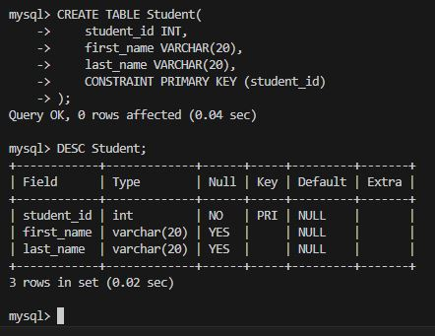

CREATE TABLE student_contact(

student_id INT,

email_address VARCHAR(30),

contact VARCHAR(15),

CONSTRAINT PRIMARY KEY (student_id),

CONSTRAINT FOREIGN KEY (student_id) REFERENCES Student(student_id)

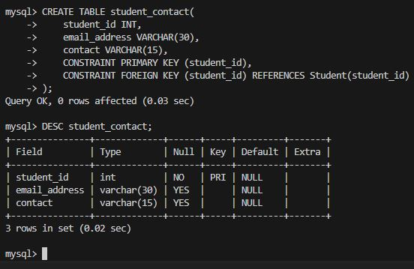);

INSERT INTO Student VALUES

(1,'Kamal','Perera'),

(2,'Nimal','Samson'),

(3,'Amal','Perera'),

(4,'Roy','Silva');

SELECT * FROM Student;

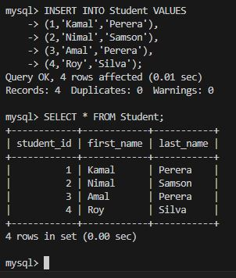

INSERT INTO student_contact VALUES

(1,'kamal@school.edu','77234512'),

(2,'nimal@school.edu','77456396'),

(3,'amal@school.edu','077743566');

SELECT * FROM student_contact;

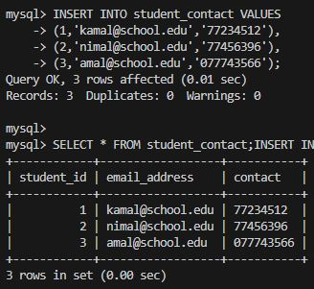

**Question 02**

SELECT student_id, first_name FROM Student;

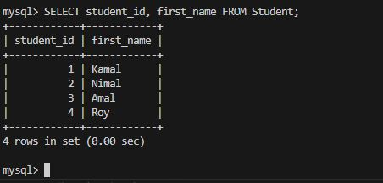

**Question 03**

SELECT Student.student_id, Student.first_name, student_contact.email_address AS Email

FROM Student

INNER JOIN student_contact

ON Student.student_id = student_contact.student_id;

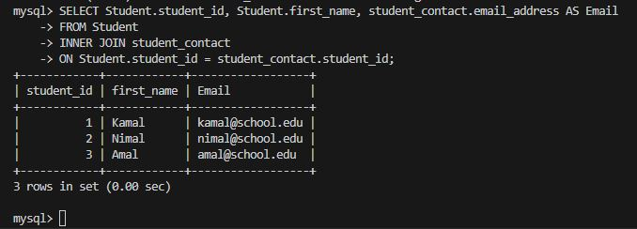

**Question 04**

SELECT CONCAT(Student.first_name,' ', Student.last_name) AS "Full Name", student_contact.email_address

FROM Student

INNER JOIN student_contact

ON Student.student_id = student_contact.student_id;

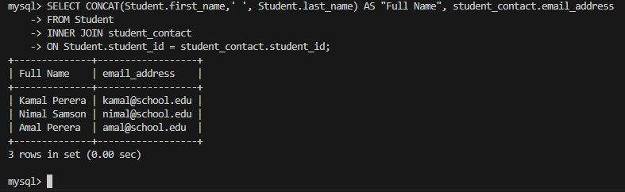

**Question 05**

SELECT Student.student_id, Student.first_name, student_contact.email_address AS Email

FROM Student

INNER JOIN student_contact

ON Student.student_id = student_contact.student_id

WHERE first_name LIKE '%mal%';

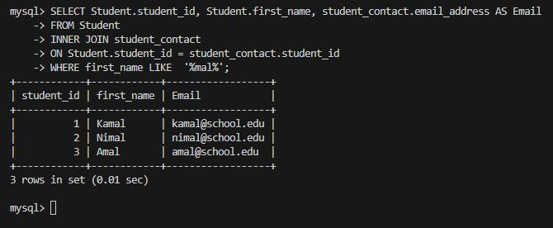

**Question 06**

CREATE TABLE DepartmentInfo(

DepartmentID INT,

DepartmentName VARCHAR(20),

CONSTRAINT PRIMARY KEY (DepartmentID)

);

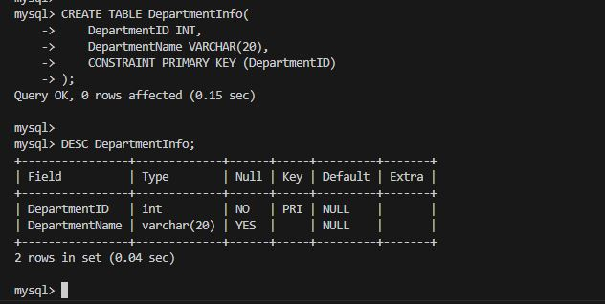DESC DepartmentInfo;

CREATE TABLE StudentInfo(

StudentID INT,

StudentName VARCHAR(20),

DepartmentID INT,

CONSTRAINT PRIMARY KEY (StudentID),

CONSTRAINT FOREIGN KEY (DepartmentID) REFERENCES DepartmentInfo(DepartmentID)

);

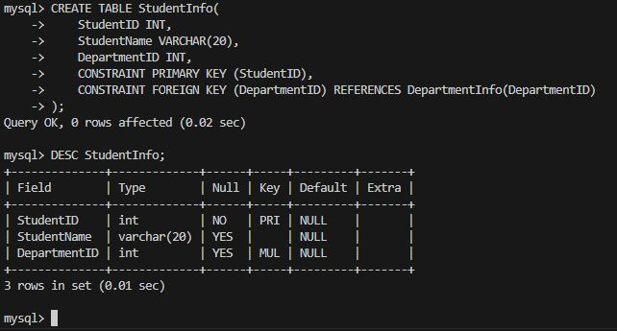DESC StudentInfo;

CREATE TABLE CourseInfo(

CourseID INT,

CourseName VARCHAR(30),

DepartmentID INT,

CONSTRAINT PRIMARY KEY (CourseID),

CONSTRAINT FOREIGN KEY (DepartmentID) REFERENCES DepartmentInfo(DepartmentID)

);

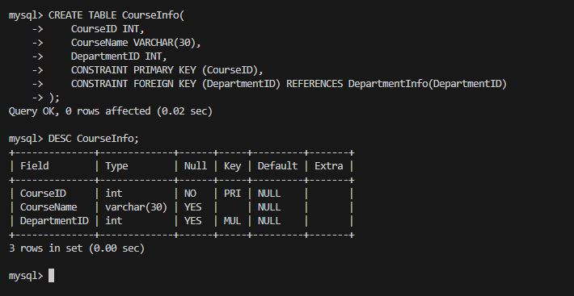DESC CourseInfo;

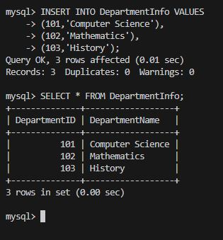

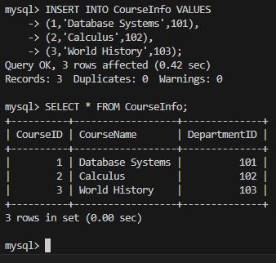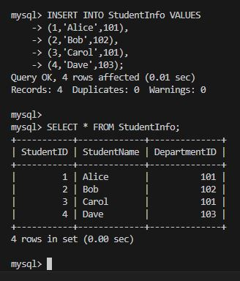

**Question 07**

SELECT StudentName, DepartmentName

FROM StudentInfo

INNER JOIN DepartmentInfo

ON

DepartmentInfo.DepartmentID = StudentInfo.DepartmentID;

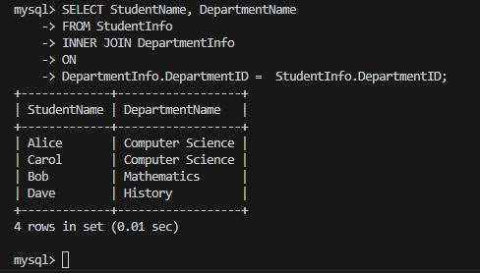

**Question 08**

SELECT StudentName, DepartmentName

FROM StudentInfo

LEFT JOIN DepartmentInfo

ON

DepartmentInfo.DepartmentID = StudentInfo.DepartmentID;

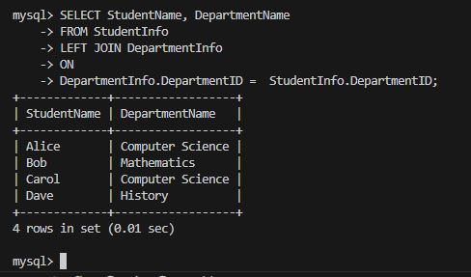

**Question 09**

SELECT DepartmentName, StudentName

FROM DepartmentInfo

LEFT JOIN StudentInfo

ON

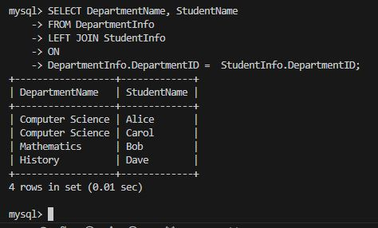DepartmentInfo.DepartmentID = StudentInfo.DepartmentID;

**Question 10**

SELECT DepartmentName,COUNT(*) AS Student_Count

FROM DepartmentInfo

LEFT JOIN StudentInfo

ON

DepartmentInfo.DepartmentID = StudentInfo.DepartmentID

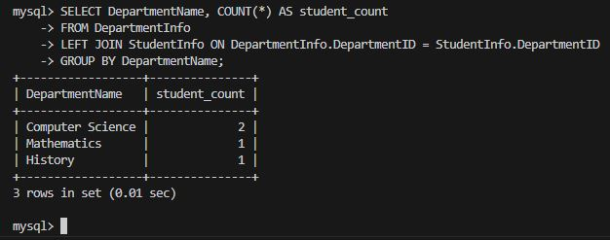GROUP BY DepartmentName;

**Question 11**

SELECT StudentName,CourseName, DepartmentName

FROM DepartmentInfo

INNER JOIN CourseInfo ON CourseInfo.DepartmentID = DepartmentInfo.DepartmentID

INNER JOIN StudentInfo ON DepartmentInfo.DepartmentID = StudentInfo.DepartmentID;

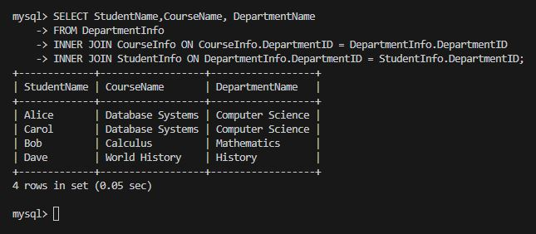

**Question 12**

SELECT StudentName AS "Student Enrolled to Computer Science"

FROM StudentInfo

INNER JOIN DepartmentInfo ON DepartmentInfo.DepartmentID = StudentInfo.DepartmentID

WHERE DepartmentName = "Computer Science";

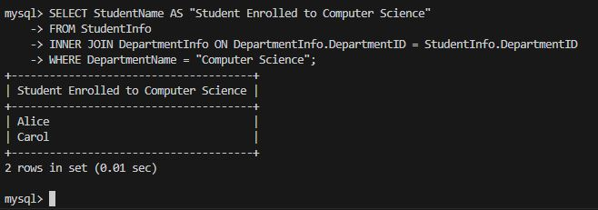

**Question 13**

SELECT DepartmentName, COUNT(*) AS student_count

FROM DepartmentInfo

LEFT JOIN StudentInfo ON DepartmentInfo.DepartmentID = StudentInfo.DepartmentID

GROUP BY DepartmentName

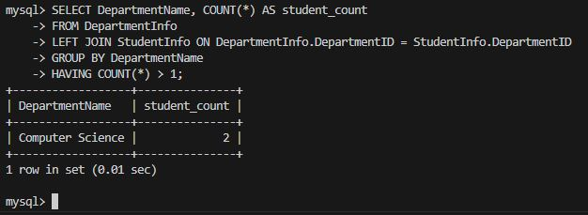HAVING COUNT(*) > 1;

**Question 14**

SELECT StudentName AS "Student Who Taking DataBase Systems Course"

FROM DepartmentInfo

INNER JOIN StudentInfo ON DepartmentInfo.DepartmentID = StudentInfo.DepartmentID

INNER JOIN CourseInfo ON CourseInfo.DepartmentID = DepartmentInfo.DepartmentID

WHERE DepartmentInfo.DepartmentName = "Computer Science" AND CourseInfo.CourseName = "Database Systems";

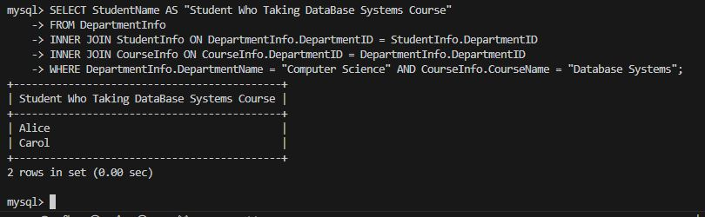

**Question 15**

CREATE TABLE Author(

AuthorID INT,

AuthorName VARCHAR(30),

Country VARCHAR(10),

CONSTRAINT PRIMARY KEY (AuthorID)

);

DESC Author;

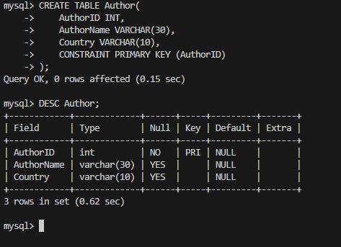

CREATE TABLE Book(

BookID INT,

Title VARCHAR(40),

AuthorID INT,

PublicationYear INT,

CONSTRAINT PRIMARY KEY (BookID),

CONSTRAINT FOREIGN KEY (AuthorID) REFERENCES Author(AuthorID)

);

DESC Book;

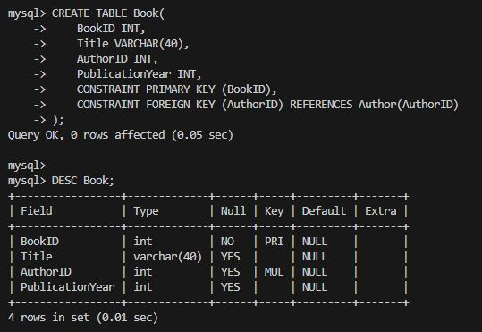

CREATE TABLE Reader(

ReaderID INT,

ReaderName VARCHAR(30),

BookID INT,

CONSTRAINT PRIMARY KEY (ReaderID),

CONSTRAINT FOREIGN KEY (BookID) REFERENCES Book(BookID)

);

DESC Reader;

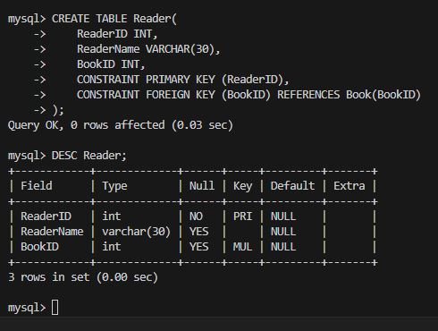

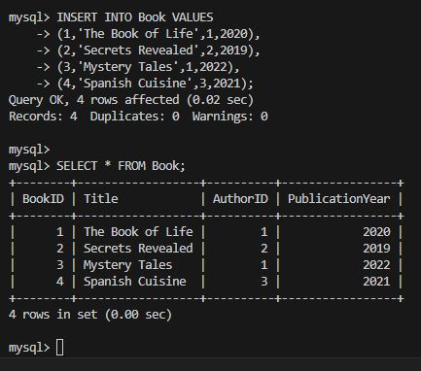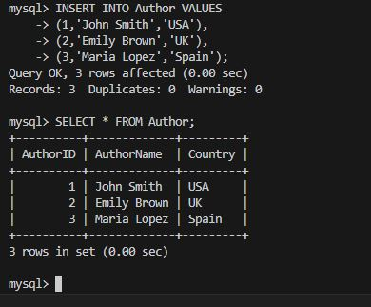

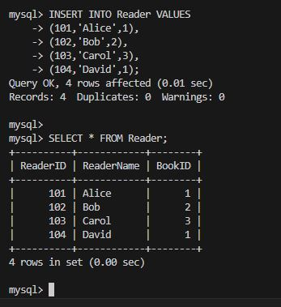

**Question 16**

SELECT Author.AuthorName, COUNT(Book.BookID) AS BooksPublished

FROM Author

INNER JOIN Book

ON Author.AuthorID = Book.AuthorID

GROUP BY Author.AuthorID, Author.AuthorName

HAVING COUNT(Book.BookID) > 0;

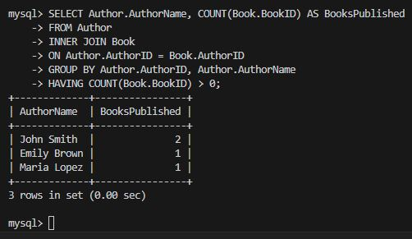

**Question 17**

SELECT Author.AuthorName, COUNT(Book.BookID) AS TotalBooks

FROM Author

LEFT JOIN Book ON Author.AuthorID = Book.AuthorID

GROUP BY Author.AuthorID, Author.AuthorName;

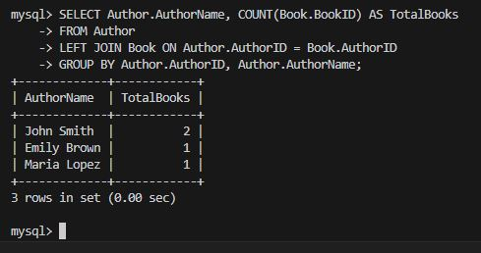

**Question 18**

SELECT Book.Title,Book.PublicationYear,Author.AuthorName

FROM Book

INNER JOIN Author ON Book.AuthorID = Author.AuthorID

WHERE Book.PublicationYear < 2020;

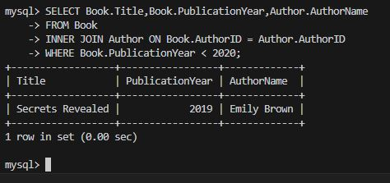

**Question 19**

SELECT Reader.ReaderName,Book.Title

FROM Reader

INNER JOIN Book

ON Reader.BookID = Book.BookID

WHERE Reader.ReaderID = 101 OR Reader.ReaderID = 102;

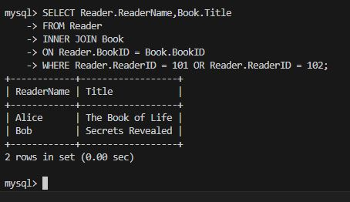

**Question 20**

SELECT Reader.ReaderName,Book.Title

FROM Reader

INNER JOIN Book

ON Reader.BookID = Book.BookID

WHERE (Reader.ReaderID = 101 OR Reader.ReaderID = 102) AND Book.BookID = 2;

